1.

**Figure 1.** Histogram of the heights (in cm) of the heather shrubs (*Calluna vulgaris*), where the ranges of values are increments of 10 units.

Our data has a kurtosis value 0.29, which indicates low leptokurtic distribution. However, our value is very close to the zero (ideal kurtosis value), and therefore we can assume that there is not a problem with our data. Our skewness is 1.05 - right-side (positive) skew. The good way how to test this type of skewness is that our mean (35.43 cm) and median (28 cm) values will be higher than the mode (4 cm). Because we have positive skewness, we may assume that our data are not normally distributed. To measure central tendency, I decided to calculate median value (28 cm). It is because we have right-skewed data and the mean is being dragged in the direct of the skew. In this case, I think that to calculate median is the best option.

2.

For investigation whether there is any association between the habitat types and the two month species, I used chi-square probabilty test.

Null hypotheis: there is no association between the habitat types and the two month species

Alternative hypothesis: there is association between the habitat types and the two month species

Our p-value (0.005) is less than 0.05, so there is a significant association between habitat type and month species. The probability that the null hypotheis being true is only 0.05% - therefore we rather reject the null hypothesis and accept the alternative one.



3.

I used Kolmogorov-Smirnov statistical test to in order to answer posed question.



Null hypothesis: There is not a significant difference of marking student’s assessments between staff member x and staff member y.

Research hypothesis: There is a significant difference of marking student’s assessments between staff member x and staff member y.

As our D=0.05<Dcrit=0.32, we accept the null hypothesis, so the marks awarded by the two academic members of staff are consistent.

Next, I produced following scatterplot:

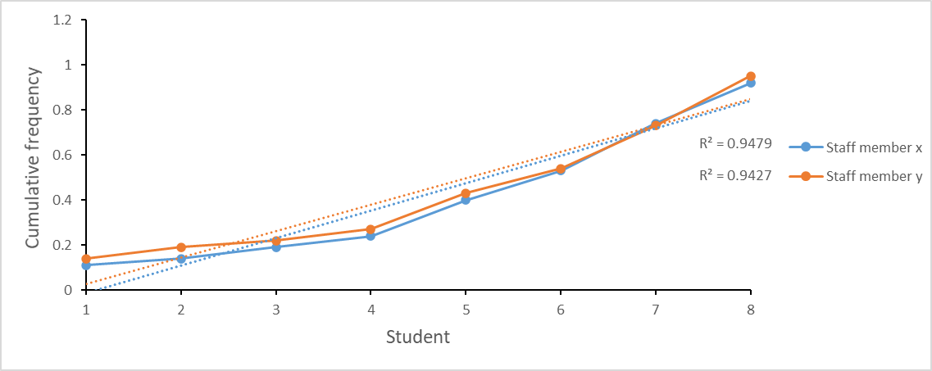

Our correlation coefficient R2= 0.94 means strong positive relationship, what also confirms that the marks are a fair reflection of the work submitted.